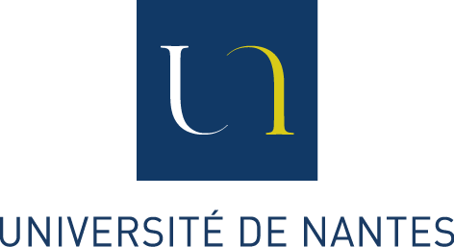
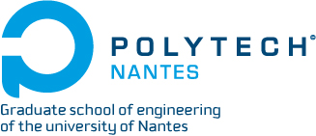
Photo

Application for Admission to

International Master Degree in Science and Technology

Period: 2014 – 2015

For the admission to an international master program, you should send us before
April 11th 2014 :
- this application form
- copies of your transcript (academic scores)
- a detailed CV
- copy of identification (passeport. ..)

The selection committee composed of the involved professors will take the final decision.

All the courses are taught in English, the tuition fees for the master program are 6500 euros for 2014-2015.

Option, please make your choice :
Electronic system (SE)
Electrical system (GE)
Multimedia and Data Management(MDM)
Thermal Sciences and Energy (TE)

Last name (Family Name): Sex: M/F
First name (Given Name):
Address:
Email:
Telephone:+
Date birth (00/00/0000): Place of birth:
Nationality:
Family status (married, single,…):

1- Education:

Year | University or School | Degree earned | Specialty | Level
2012

2- Experiences: Internships and employments

Year | Duration | Company or Lab | Subject | Internship or employee

3 - Other experiences:

4-Motivation: (10 lines)

5- Miscellaneous
Level of English (reading, writing):

Software competencies:

Source of funds: (where will the money come from to pay for this program?)

VERY IMPORTANT: (not for EU students)

Many countries have compulsory process through Campus France.
You should check if your country adheres to this procedure by visiting the website http://www.campusfrance.org/en

If so, you must also complete the Campus France (CEF) procedure on the website

and tell us your CEF number :

Please send your application to : Ms Clotilde de Coudenhove,
Incoming Mobility, International Relations Department
Clotilde.decoudenhove@univ-nantes.fr

